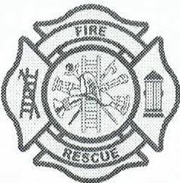
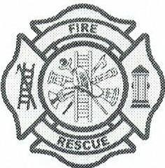
CLINTON FIRE PROTECTION DISTRICT
SINCE 1962
Proudly Serving the Village of Clinton and the Townships of Bradford and Clinton
PO BOX 153 145 Ogden Ave. Clinton, WI 53525-0153

Community Event Request Form

Name:____________________________ Organization or Business:______________________
Phone Number:_(____)________________ Email Address:_______________________________

Event Title:______________________________________________________
Event Location:___________________________________________________

Event Description:_______________________________________________________________
_____________________________________________________________________________
_____________________________________________________________________________
Event Date:_______________ Start Time_____________AM/PM End Time_____________AM/PM
Contact Name for Event:__________________________ Phone Number:__(____)_______________

Requested Vehicle(s): Ambulance Engine

Is the vehicle providing service for the event? YES NO

If yes, what type of service? EMS Level: Basic Paramedic

Fire Suppression Type: Structure Wildland

Please return filled out forms to 145 Ogden Ave, Clinton WI, 53525, Monday - Friday 7:00 am to 5:00 pm or email a copy to clintonemswi@gmail.com. A staff member will be in contact with you to go over your request form.
Clinton Fire Protection District and its staff will try to fully fill all requests submitted. However, CFPD and its staff cannot control when emergency calls arise. This could cause us to show up late, leave early, or unfortunately prevent us from attending. Thank you for your understanding.

**Please keep in mind CFPD staffs one ambulance 24/7 for our community. Providing any additional** services preventing our crew responding to our community needs would require additional staffing, which may result in a fee being requested.

